GENERIC HOTEND OVERVIEW
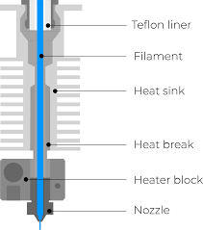

NOZZLE TYPES
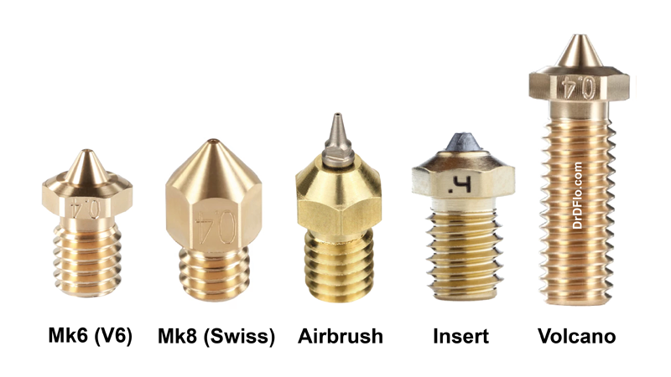

HEATER BLOCK TYPES
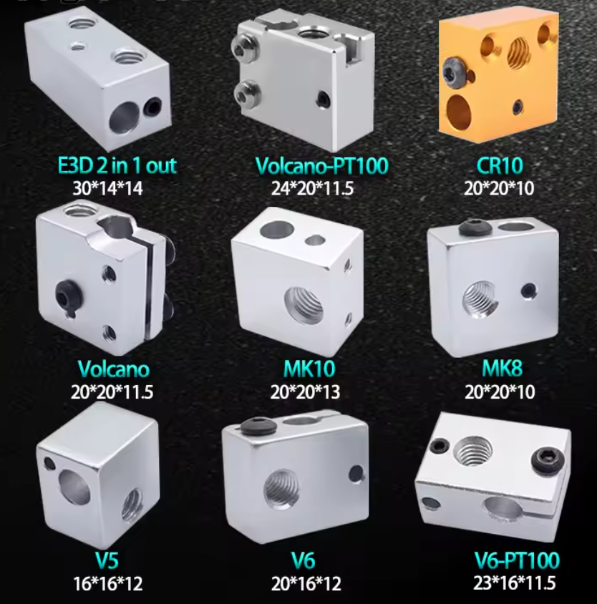

HEAT BREAK TYPES
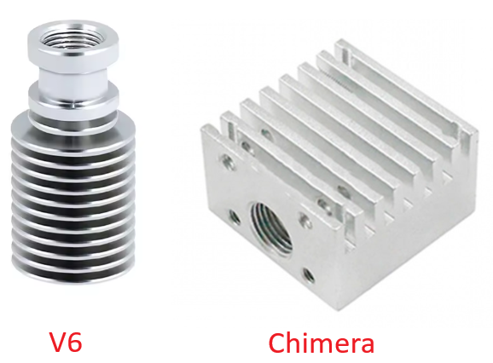

BLUER ORIGINAL PATS
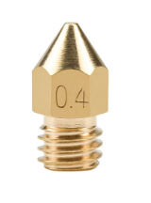  Nozzle: MK8 | 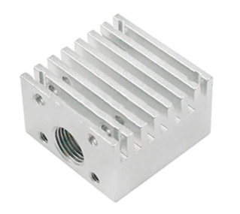  Heat sink: Chimera (same as “Kraken” and “Cyclops”)
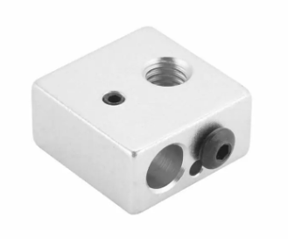  Heater block: MK8 | 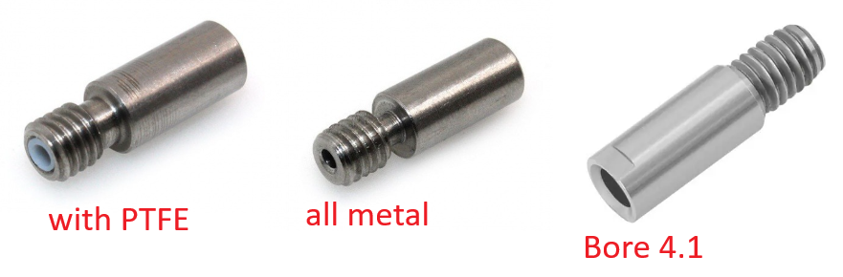  Heat Break: Chimera (same as “Kraken”)

